OPEN POLISH CUP U15

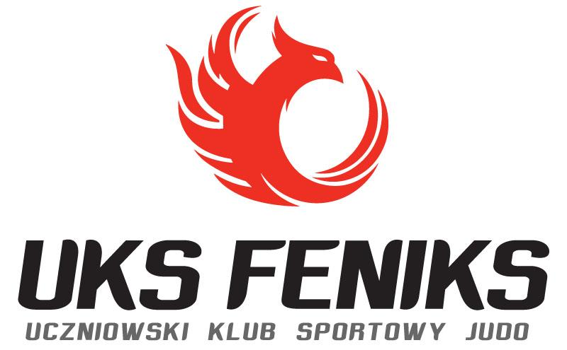
COMMUNICATION 20.03.2026
- Organizers: Polish Judo Association, UKS FENIKS Bytom
- Venue: Sports Hall, “Na Skarpie”, Bytom, ul. Frycza-Modrzewskiego 5a
- Date of competition: 28.03.2026
- Person responsible from UKS FENIKS Bytom: Wojciech Wysocki
- Competition office: Aleksandra Zarzecka / secretariat.feniks@gmail.com, tel +48 517818512
- Contact: Office no. +48 517818512, Wojciech Wysocki +48 501269171
- Competit Director: Marek Słyk
- Head of Competition: Marzena Błachnio
- Board Delegated: TDB
- Participation:
Entry fee: 130PLN per registered athlete.
Please send confirmation of entry fee payment and invoice details to
sekretariat.feniks@gmail.com and zawody@pzjudo.pl along with a list of the names of athletes registered for the competition. The invoice will be sent to you by email after payment is received.

Entry fee payable by bank transfer to the following account number:

UKS FENIKS Bytom

51 1750 0012 0000 0000 3829 6628

ul. Chrzanowskiego 3/13, 41-902 Bytom, NIP 6263004234

Please enter the following in the subject line: club name + OPC Bytom. Entry fee paid by bank transfer before the competition is required for entry. Cash payments during the competition are not possible.

27.03.2025 r. (friday) Hotel Przy Skarpie, Bytom, ul. Killara 29
15:00-20:00 | Tournament officie – accreditation
17:00-18:00 | Check Weighin
17:30-18:30 | Verification for individual competitions in all weight categories: entry corrections, verification of start lists, verification and reporting of competition seedings.
18:00-19:00 | Unofficial weight
19:00-20:00 | Official weight: U15
28.03.2025 r. (sobota) Hala „Na Skarpie”, Bytom, Frycza-Modrzewskiego 5a
8:00-19:00 | Competit office
7:00-8:00 | Official weight for men U15
8:00-8:45 | Technical conference and draw OPC
8:00-8:45 | Judge’s briefing, warm-up, random weight men U15 weighed 27.03
8:45-9:00 | Opening tournament
9:05 | Elimination and repechage fights men U15 (+bronze medal contests)
11:00-11:45 | Official weight for women U15, random weight women U15 weighed 27.03
12:45 | Elimination and repechage fights women U15 (+bronze medal contests)
 | Finals block (only gold medal contests) 10’ after eliminations and repechage fights
 | Decoration ceremony

OPC U15 – Official Communication (English Version)
NOTE! The competition program and schedule may be subject to change depending on the number of entered and verified athletes. The final order of weight categories will be announced after the technical conference on Telegram – #PZ Judo Zawody.
11. Rules of Participation:
a) In OPP, all athletes from foreign clubs and athletes from Polish clubs holding a valid PZ Judo license and valid sports-medical examinations (medical certificate) in accordance with the PZ Judo Regulations are eligible to compete.
b) Polish clubs registering athletes for the competition must hold a valid club license of the Polish Judo Association.
c) COACHES – The Dress Code rules and the Code of Conduct for Judo Coaches apply.
12. Age category, training level, match duration, competition system:
a) Birth years in the U15 Youth category: 2012 and 2013.
b) Minimum grade: 5th kyu in U15 Youth.
c) Match duration: 3 minutes + GS (Golden Score – unlimited time).
d) In the U15 category, the competition will be held on six 6 x 6 m tatami mats, using a system in accordance with the Sports Regulations of the Polish Judo Association.
e) The competition will be conducted in accordance with the PZ Judo Sports Regulations.
13. Weight Categories:
U15 Girls:
-36 kg, -40 kg, -44 kg, -48 kg, -52 kg, -57 kg, -63 kg, -70 kg, +70 kg
U15 Boys:
-35 kg, -38 kg, -42 kg, -46 kg, -50 kg, -55 kg, -60 kg, -66 kg, -73 kg, -81 kg, -90 kg, +90 kg
14. Competition Entries (until 24.03.2026 – Monday)
Clubs must submit entries no later than 4 days before the competition, i.e. until 24.03.2026 (Tuesday) by 12:00 noon, exclusively via the electronic system:
https://admin.judomanager.com
Entries submitted in any other form (e-mail, fax, etc.) will not be accepted.
Correction procedure (change of weight category or withdrawal of entry):
a) From 24.03 (Tuesday) 12:00 until 26.03.2026 (Thursday) 23:59 – notification by e-mail to: zawody@pzjudo.pl and simultaneously to: sdm.slovakia@gmail.com
b) During verification for the competition – according to the competition schedule.
Late entry – a regulatory penalty in the amount of double the entry fee will apply.
The penalty must be paid no later than the end of verification (PZ Judo Sports Regulations).
WARNING! If a Club does not have a user account in the JudoManager application or has problems logging in, please contact Stanislav Mlynaric by e-mail and send a message to: sdm.slovakia@gmail.com and zawody@pzjudo.pl to obtain access.
Weigh-in, weight tolerance:
a) During the official weigh-in, athletes must present an identity document.
b) In U15 competitions there is no weight tolerance for clothing. Athletes must weigh in wearing underwear only.
15. Random Weigh-in:
a) Random weigh-in is conducted in accordance with point 2.7.6 of the PZ Judo Sports Regulations.
b) The same procedures apply as for the official weigh-in. The athlete’s weight may not exceed 5% of the official weight category limit. Selected athletes have the right to only one unofficial weigh-in attempt.
c) PZ Judo or the Competition Commission may resign from conducting the random weigh-in. Information whether the random weigh-in will be conducted will be announced during the coaches’ conference at the draw.
16. Refereeing Matters:
a) Referee meeting according to the program.
b) Refereeing in accordance with the current IJF competition rules, including the provisions contained in the IJF Rules document.
17. Transport:
On own responsibility / at own expense.
18. Accommodation for Athletes and Coaches:
Hotel Lantier ****
Ul. Krzyżowa 24, 41-909 Bytom
Double room without breakfast – 260.00 PLN/night
Triple room without breakfast – 360.00 PLN/night
Quadruple room without breakfast – 460.00 PLN/night
Breakfast – 50 PLN/person
Dinner – 50 PLN/person
Hotel Boutique ***
Ul. Konstytucji 91, 41-905 Bytom
Single room with breakfast – 205.00 PLN/night
Double room with breakfast – 280.00 PLN/night
Triple room with breakfast – 395.00 PLN/night
Hotel B&B ***
Ul. Strzelców Bytomskich 87C, 41-914 Bytom
Single room with breakfast – 230.00 PLN/night
Double room with breakfast – 320.00 PLN/night
Triple room with breakfast – 400.00 PLN/night
Hotel “Przy Skarpie” ***
Ul. Kiliara 29a, Bytom
Double room with breakfast – 280 PLN/night
Triple room with breakfast – 390 PLN/night
Twój Hostel **
Ul. Magazynowa 39, 41-700 Ruda Śląska
Double room with bathroom and breakfast – 220.00 PLN (breakfast served in “Desperado” restaurant)
Triple room with bathroom and breakfast – 295.00 PLN (breakfast served in “Desperado” restaurant)
Triple room without bathroom, with breakfast – 235.00 PLN (breakfast served in “Desperado” restaurant)
Quadruple room without bathroom, with breakfast – 310.00 PLN (breakfast served in “Desperado” restaurant)
*It is possible to order accommodation without breakfast.
19. Accommodation for Referees and Delegates:
Hotel “Przy Skarpie” ***
Ul. Killara 29a, 41-909 Bytom
20. Catering:
During the tournament, a grill and buffet with coffee, tea and snacks will be available in the competition hall. It is possible to order lunches at a price of 35.00 PLN. Meal orders will be accepted until 20 March. After this date, accommodation and meals are not guaranteed.
Meal reservations should be sent by e-mail to: biuro.feniks.bytom@gmail.com
Consumption of meals in the stands is prohibited. Meals may only be consumed in designated areas.
21. Awards and Prizes:
1st–3rd place – medals
1st–5th place – diplomas
1st place – sports T-shirt
22. Judogi:
a) OPP U15 – the second called athlete wears a blue judogi or a white judogi with a red belt.
b) Girls must wear a white T-shirt under the judogi.
c) Judogi control is conducted in accordance with Sokuteiki rules described in Chapter 5 of the PZ Judo Sports Regulations.
d) For the medal ceremony, a white judogi is mandatory.
23. Other:
a) Current competition information will be published on the PZ Judo information channel in the Telegram application – PZ Judo Zawody.
b) Entry to the competition zone is allowed only on the basis of athlete accreditation, coach accreditation, or invitation.
c) During accreditation, coaches must submit parental/legal guardian consents for minor participants.
d) Athletes, coaches and guardians must have accident insurance (NNW). Responsibility for providing insurance lies with the delegating clubs/entities.
e) Athletes must possess a valid medical certificate in accordance with current regulations. The athlete is responsible for the validity of medical examinations; in the case of a minor athlete, the parent or legal guardian is responsible. The club is obliged to verify the validity of examinations.
f) The Organizer is not responsible for incidents that may occur.
24. Basic Rules of Participation:
All participants of the competition – clubs, coaches, officials and athletes – must accept and respect the authority of PZ Judo representatives, the PZ Judo Statute, the PZ Judo Sports Regulations, IJF refereeing rules, POLADA Anti-Doping Rules, as well as safety rules designated by the Organizer. Persons recognized as acting against these rules may be suspended or removed from the event.
We wish you a pleasant stay in Bytom!

